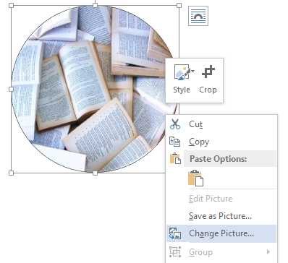
How to Insert an Image
Using the Button Template on Word

- Right click on circle
- Select “Change Picture”
- Select “Browse” under “From a File”
- Browse and double click on desired image

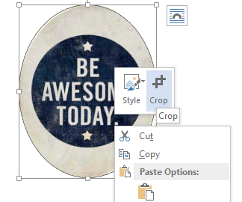

- Circle will stretch to fit the photo. Right click on the image
- Select “Crop”
- Drag black corner piece of the oval to reshape it into a circle
- Drag the white corner piece of the image until it fills the circle. Reposition the image to the center of the circle.
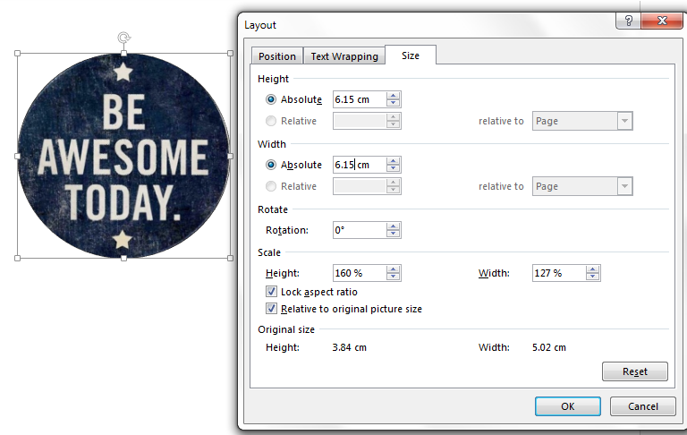

- Right click on circle
- Select “Size and Position”
- Type “6.15 cm” into both the Absolute Height and Width boxes

Your button is ready to print!

