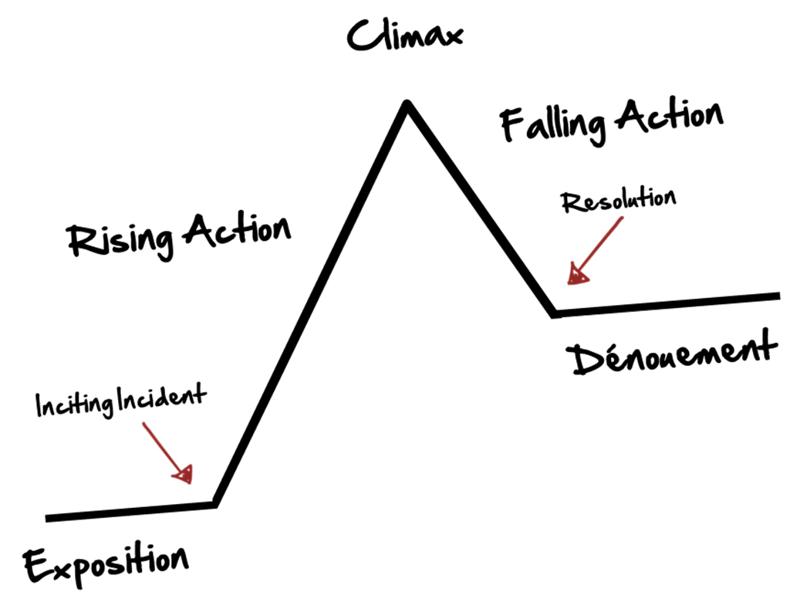
Plot Arcs (or Story Arcs)
Exposition: The introduction of the story – the scene is set, the characters are introduced, and a tone is created

Inciting Incident: Something happens that includes conflict and changes the “normal” life of the main character

Rising Action: a series of events that result from the Inciting Incident and create suspense

Climax: The most exciting moment in the story where everything comes together – could be a huge decision the main character makes, or a dramatic fight between the hero and the villain.

Falling Action: a series of events that show how the characters react to the Climax

Resolution: the conflict created by the Inciting Incident is resolved

Denouement: the conclusion to the story – how does everything end?

Exposition (or Introduction)
What details and backstory do you want the audience to know before the story really begins?
What character traits do you want to reveal about your main character (known as the “protagonist”)? ______________________________________________________________________________________________________________________________________________________________________________
What is the setting of your story? ______________________________________________________________________________________________________________________________________________________________________________
What tone do you want the story to have? (scary, romantic, intense, light-hearted, etc) ______________________________________________________________________________________________________________________________________________________________________________
Inciting Incident
This is one of the most dramatic points in the story. Everything changes and the real action begins. Think about what will happen to your character, and how to write it in a suspenseful way.
What is the inciting incident in your story? ______________________________________________________________________________________________________________________________________________________________________________
Write the first draft of your incident:
__________________________________________________________________________________________________________________________________________________________________________________________________________________________________________________________________________________________________________________________________________________________________________________________________________________________________________
Rising Action
This is when the conflict begins to increase, building towards the most intense part of the story.
How does your character feel about the inciting incident? (think about the character traits you assigned them) ______________________________________________________________________________________________________________________________________________________________________________
How would your character react to the inciting incident? ______________________________________________________________________________________________________________________________________________________________________________
How will you maintain the tone of your story? ______________________________________________________________________________________________________________________________________________________________________________
Climax
The most intense part of the story – your character must face the conflict head on!
What conflict must your character face? ______________________________________________________________________________________________________________________________________________________________________________
How can you make it an exciting moment that will keep readers interested?
____________________________________________________________________________________________________________________________________________________________________________________________________________________________________________________________________________________________________________________________________________________________

Falling Action
This is when the conflict begins to decrease, building towards the resolution and conclusion. How does your character feel about the climax? (think about the character traits you assigned them) ______________________________________________________________________________________________________________________________________________________________________________
What needs to happen for the conflict to be resolved? ______________________________________________________________________________________________________________________________________________________________________________
How will you maintain the tone of your story? ______________________________________________________________________________________________________________________________________________________________________________
Resolution
How will the conflict be resolved? ______________________________________________________________________________________________________________________________________________________________________________
How can you make it an exciting moment that will keep readers interested?
_____________________________________________________________________________________________________________________________________________________________________________________________________________________________________________________________________
Conclusion
What happens to your character after the conflict is resolved? How do they feel? _____________________________________________________________________________________________________________________________________________________________________________________________________________________________________________________________________

